Emergency:
Ambulance………………………………………………………………………....911
Fire……………………………………………………………………………..…..911
Police…………………………………………………………………………….…911
Non-Emergency Police Department Number…………………………...913/971-7500

Area Businesses:

Automobile Repair/Parts:
Firestone Rubber and Tire Company, 15050 W 135th St……………. ……….782-1833
Goodyear Tires, 15187 W. 119th…………………………………………..…..397-8848

Banks:
Bank Midwest, 14735 W 119th St…………….………………………………829-1835
Capital Federal, 15345 W. 119th……………………………………………....381-5400
Hillcrest Bank, 11960 S. Strang Line Rd. ………………………………….....397-0202
M&I Bank, 15203 W. 119th…………………………………………………...254-6627
U.S. Bank, 15380 W. 119th…………………………………………………....324-3939

Books:
Brook Mays Music, 11943 Strang Line Rd. …………………………………..829-8741
Half-Price Books, 15309 W. 119th………………………………………….....829-9959

Cellular Phone Service:
Cingular, 15281 W. 119th……………………………………………………...397-0600
Sprint/Nextel, 13425 Black Bob……………………………………………….390-6366
T-Mobile, 14359 W 119th St…………….…………………………………….254-1674
Verizon, 15235 W. 119th……………………………………………………....393-1285

Cleaners:
Pride Cleaners, 14940 W. 119th……………………………………………….780-4625
Mona’s Alterations & Cleaners, 14032 W. 119th St…………………………393-0115

Coffee/Espresso:
Starbucks, 14605 W. 119th……………………………………………………..829-1728

Electronics:
Batteries Plus, 15135 W 119th St……………………………………………...390-6601
Best Buy, 11750 S. Strang Line Rd………………………………………..…..829-0492
Radio Shack, 15206 W. 119th………………………………………………….254-7818

Health and Beauty:
Affordable Supplements, 14950 W. 119th……………………………………..390-6599
Beauty Brands, 15225 W. 119th……………...………………………………..393-4800
BQ Nails, 14170 W 119th St…………………………………………………...393-4777
Fantastic Sams, 14920 W. 119th……………………………………………….782-7400
General Nutrition Center (GNC), 15163 W. 119th…………………………….390-0414
Great Clips, 2016 Santa Fe…………………………………………………….780-2016
The Hairem, 12011 S. Strang Line Rd………………………..……………..…829-1260
ULTA, 14677 W. 119th………………………………………………………...254-1922

Home Furnishings:
Bed, Bath & Beyond, 15335 W. 119th………………………………………….782-4454
Home Goods/Marshalls
Pier One, 15340 W. 119th…………………………………………………..…..393-3528

Hotel:
Hampton Inn, 12081 S. Strang Line Rd…………………………………....…..397-9394
Radisson Hotels, Interstate 35 And 95th………………………………………..888-6670

Ice Cream and Desserts:
Baskin Robbins, 11912 S. Strang Line Rd……………………………………..764-0031
Coldstone Creamery, 14941 W. 119th……………………………………….....269-1610
Sylas and Maddy’s, 11925 S. Strang Line Rd……………………………….....393-3500

Jewelry:
Noble House, 15311 W. 119th……………………………………….………….764-5338
Visionary Jewelers, 14146 W 119th St…………………………………………782-1177

Libraries:
City of Olathe, 201 E. Park……………………………………………………..971-6850
Indian Creek Branch, 12990 S. Black Bob Rd…………………………………971-5235

Movies/Games/Entertainment:
AMC Movie Theatres, 12075 Strang Line Rd………………………………….393-2262
Movies and Showtimes……………………………...…………………...393-4262
Game Stop, Olathe Station II……………………………………………………397-7077
Game Exchange, 15159 W. 119th……………………………………………….254-1676

Office Supplies:
Office Max, 15315 W. 119th…………………………………………………….780-5554

Parks & Recreation:
Administration, 200 W. Santa Fe……………………………………………….971-6263
Parks and Public Ground, 200 W. Santa Fe…………………………………….971-6038
Recreation Division, 200 W. Santa Fe………………………………………….971-6263
Recreation Activity Registration

Party Supplies:
Party America, 13511 S. Mur-Len……………………………………………...829-4448

Pet Care/Supplies:
Olathe Animal Hospital, 13800 W. 135th……………………………………….764-1415
Petsmart, 15255 W. 119th……………………………………………………….393-4111

Pharmacy:
Target Pharmacy, 15345 W. 119th………………………………………………782-8756

Restaurants:
A&W, 11990 S. Strang Line Rd…………………………………………………768-4141
Burger King, 11911 S. Strang Line Rd…………………………………………..764-6863
Carraba’s Itailian Grill, 12210 S. Strang Line Rd………………………………..397-8377
Celebrity’s Sidewalk Cafe, 15175 W. 119th………………………………….......764-4870
Chipotle Mexican Grill, 15100 W. 119th…………………………………………393-3319
Gambino’s Pizza, 14960 W. 119th……………………………………………….390-0400
Granite City Food & Brewery, 15085 W. 119th………………………………….829-6060
Haru’s Japanese Steakhouse, 15202 W. 119th…………………………………....780-1118
International House of Pancakes (IHOP), 15410 W. 119th………………………393-2174
Joe’s Crabshack, 11965 S. Strang Line Rd……………………….……………...393-2929
Johnny Carino’s Country Italian, 14805 S. Strang Line Rd……………………..782-0748
Long John Silver’s, 11990 S. Strang Line Rd…………………………………...768-4141
McDonald’s, 12091 S. Strang Line Rd…………………………………………..764-7390
Noodles & Co., 15208 W. 119th………………………………………………….829-4848
Old Chicago, 11969 S. Strang Line Rd…………………………………………..764-9850
Olive Garden, 15090 W. 119th…………………………………………………...768-4372
Panera, 15108 W. 119th…………………………………………………………..782-3066
Planet Sub, 15157 W. 119th………………………………………………………390-6221
Popeye’s, 15202 W. 119th………………………………………………………..768-8778
Ruby Tuesday, 15400 W. 119th…………………………………………………..397-7829
Schlotsky’s, 12221 S. Strang Line Rd……………………………………............782-2867
Smokin’ Joe’s BBQ, 519 E. Santa Fe…………………………………………….780-5511
Subway, 13770 Black Bob……………………………………………………….397-9030
Texas Roadhouse, 11973 S. Strang Line Rd……………………………………..397-8222
Wendy’s, 11970 S. Strang Line Rd………………………………………………768-6388
Zio’s Italian Cuisine, 11981 S. Strang Line Rd…………………………………..782-2225

Shopping:
Dress Barn, 14655 W. 119th…………………………………………………...…397-9145
Famous Footwear, 15420 W. 119th………………………………………………390-0585
Justice (for girls), 14669 W. 119th……………………………………………….782-5519
Marshalls,14645 W 119th St……………………………………………………..764-6336
Off Broadway Shoes, 14695 W. 119th…………………………………………...829-5566
Old Navy, 15290 W. 119th……………………………………………………….780-4193
Target, 15345 W. 119th…………………………………………………………...393-4400

Sporting Goods:
Bike America, 15289 W. 119th…………………………………..………………780-4500
Dicks, 15280 W. 119th……………………………………………………………254-9196
Dimples Golf, 11951 S. Strang Line Rd………………………………………….390-6444
Golf MD, 11505 S. Strang Line Rd………………………………………………663-5050

Tanning:
Solarium Tanning Salon, 15240 W. 119th………………………………………..254-1922
Tan World, 11914 S Strang Line Rd……………………………………………..829-5188

Wine and Spirits:
Top Cellars, 119th & Quivira……………………………………………………..484-9856
Wine and Spirits(Coleman Liquor), 15161 W. 119th…………………………….782-7369

Welcome To
AVIGNON HOMES

Turns Ordinary Life Into Extraordinary

The AVIGNON Community is a unique lifestyle with single family homes, retail shops, and apartment homes with a private community clubhouse and spa.

The Management and Staff of AVIGNON are delighted to introduce you to your spacious new home. AVIGNON maintenance-free villa homes afford luxury and comfortable living. Within the community are retail shops within walking distance providing dining and shopping opportunities.

Price Brothers, a master developer, has built homes, apartments and retail shops to guarantee quality and fine living.

AVIGNON features a spa, fitness facilities, steam rooms, tanning beds, massage therapy, coffee bar, game room, meeting room and concierge services to be enjoyed by the entire community.

Full-time Concierge services include assistance with packages, drop-off dry cleaning service, event scheduling and much more. The fitness area features state-of-the art fitness equipment designed for cardiovascular and fitness training along with areas for Pilates. Spa areas for men & women feature steam rooms, tanning rooms, massage therapy, cool-down areas, lockers and showers. The entertainment areas include a coffee shop, seating areas, computer stations and Wi-Fi. For your convenience, there is a meeting room and prep kitchen for resident functions including parties, social groups and other events. Unwind in the game room complete with billiards and darts. Utilize the resident services area providing shopping materials, copier & fax services, and community notices. Reserve one of three private cabanas surrounded by an elegant swimming pool, outdoor dining area and loggia featuring a built-in cooking area and outdoor fountains.

AVIGNON is the home you’ll never want to leave.

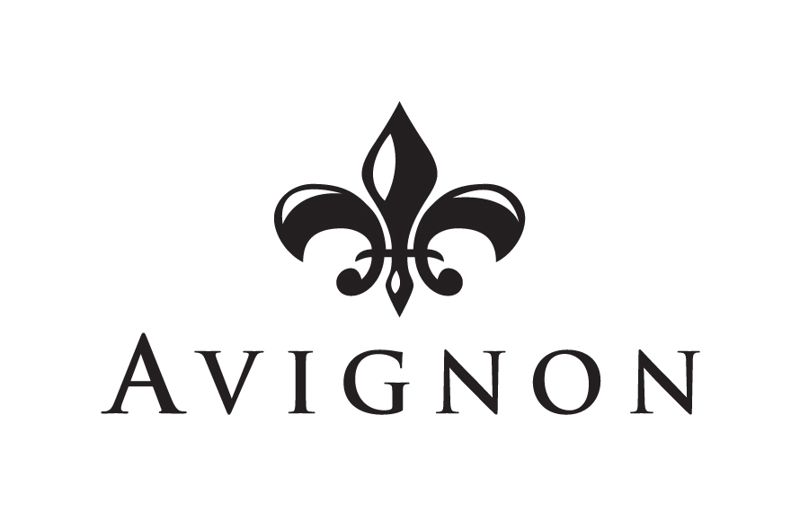

Avignon Homes
14245 W. 117th Court
Olathe, Kansas 66062
913/390-8888

GENERAL INFORMATION

Concierge Office:
Phone……………………………………………………..…..913/390-8888
Fax……………………………………………………………913/390-8887

Concierge Hours
Monday-Friday……………………………………… 9:00 a.m. – 8:00 p.m.
Saturday………………………………………………..9:00 a.m. – 6:00 p.m.
Sunday…………………………………………………12:00 p.m.- 5:00 p.m.

Notary Service:
The Concierge, and the Property Manager are notaries and would be glad to notarize your signature at no charge.

Package Delivery:
Postal, UPS, and Federal Express packages will be accepted in the clubhouse at the concierge desk. You may pick them up during normal business hours.

Communication:
From time to time it is necessary to send important notice to all residents. The location to check for notices is in the Resident Service Center. Please direct all questions and concerns you may have to your Community Association Manager.

SPA & CLUBHOUSE/
RECREATIONAL
FACILITIES

Resident Service Center:
The service center is equipped with a fax machine, copy machine, newspapers, magazines, movies and soda machines. There are complimentary DVD movies that may be checked out for up to two days at no charge. The coffee bar provides coffee, espresso, tea or hot chocolate within seconds.

Business Center:
There are three computers located by the coffee bar and a printer in the business center for residents to use. The computers have internet accessibility. The log in is Avignon Residents. The business center fax is available for use to residents, long distance faxes are not allowed. The business center closes at 8:00 p.m. Monday through Friday, Saturday at 6:00p.m., and 5:00 p.m. Sunday. The entire clubhouse and pool area is also equipped with Wi-Fi for your use.

Fitness Center:
The 24 hour fitness center is equipped with cardiovascular, weight training equipment along with areas for workout classes and other fitness activities. For information regarding personal training, fitness classes, massage therapy and prices, please call the concierge.

Tanning Bed:
The tanning beds are located in the men’s and women’s locker rooms. The tanning beds are first come first serve. No appointment is required to use the tanning beds. Please bring your own goggles. Nobody under the age of 18 is allowed to use the tanning beds.

Swimming Pool:
The pool is open seasonally from 10:00 a.m. until 10:00 p.m. Children under 18 must have an adult with them when using the pool or clubhouse. There is a two person limit for guests per home. Please accompany your guests, and carry the yellow amenity pass at all times when using the clubhouse or pool facilities. To inquire about reserving a cabana and fees, please contact the concierge.

Car Wash:
The car wash station is located NW of Building 24, attached to the maintenance shop. It is open 24 hours a day from April-October, and seasonally after that.

Smoking Not Permitted:
Smoking is not permitted in the clubhouse & spa facility. Smoking is allowed in designated areas in the loggia and pool area.

Private Parties:
The clubhouse may be reserved for private parties during non-business hours. The management reserves the right to restrict the size of private functions, the use of alcoholic beverages and the activities. Please contact the concierge for information on available dates, deposit information and fees. The loggia and pool are not rentable areas.

Etiquette:
The Avignon Spa & Clubhouse is for the use and enjoyment of all residents. Proper attire is required in all areas of the clubhouse and pool facilities. Shirt and shoes are required in all areas of the clubhouse. Swimming apparel shall only be worn in the pool area of the facility.

Rules & Regulations:
The management reserves the right to enact and enforce reasonable rules and regulations to ensure that the facility is enjoyed by all members of the community. Residents shall be responsible for the activities of guests and shall be liable for all damage to the community caused by the residents and/or their guests.

24 Hour Access Cards:
24 hour access cards are available at the concierge desk. There is a $20 fee per card. Access cards allow 24 hour access to the fitness and spa areas. The access card will also allow access to the pool during pool hours without having to go through the clubhouse.

Amenity Pass:
The yellow amenity passes are available at the concierge desk for no charge. The amenity pass is for identification purposes only. Please have the amenity pass with you when utilizing the facilities in order to identify yourself if needed. The amenity pass is also used for identification at the pool during the summer months.

Conference Room:
The conference room is a rentable space available on a sign-up basis. The party size is limited to 30 people and comes equipped with a full-kitchen. The room is rentable during normal Clubhouse hours, up to 4 hours at a time, and limited to once per month. Please contact the Concierge for other reservation information.

NEWCOMER INFORMATION

Avignon Concierge……………………………………………………..913/390-8888

Emergency…………………………………………………………………………911

Electric:
Kansas City Power & Light…………………………………1/877-962-7827

Telephone:
AT&T....................................................................................... 1/800-464-7928

Cable/Internet/Telephone:
Comcast……………………………………………………….1/888-266-2278

Post Office:
Olathe East………………………………………………………913/764-1283
15050 W. 138th St., Olathe, KS 66062

Self Storage Facility:
Attic Storage…………………………………………………….913/906-9000

School Information:
Olathe School District…………………………………………..913/780-7000
www.olatheschools.com

Walnut Grove Elementary………………………………………913/780-7710
11800 Pflumm, Olathe, KS. 66062

Pioneer Trail Junior High……………………………………….913/780-7270
15100 W. 127th Street, Olathe, KS 66062

Olathe East High School………………………………………..913/780-7120
14545 W. 127th Street, Olathe, KS 66062

